🎌 ANIME DATA PRIVACY LABs
Python Coding Laboratory Workbook
k-Anonymity | l-Diversity | t-Closeness

Student Name: DIOMON, DARAKAN, VAGILIDAD and FADRILLAN
________________________________________
Section / Course: BSINFO 3C
_______________________________________________
Date Submitted: June 30, 2026
_______________________________________________

Introduction to the Lab Workbook

This workbook contains six (6) hands-on laboratory activities covering three foundational data anonymization techniques: k-Anonymity, l-Diversity, and t-Closeness. Each technique has two activities of increasing complexity.
All datasets and scenarios are themed around anime fandom, character databases, streaming platforms, and fan communities. Each lab is implemented in Python — you will write, run, and reason through real code.

Learning Objectives
- Implement k-Anonymity, l-Diversity, and t-Closeness algorithms in Python from scratch.
- Use pandas DataFrames to manipulate, group, and verify anonymized datasets.
- Detect equivalence class violations programmatically and apply generalizations.
- Simulate linkage attacks and understand their defenses through code.
- Compute Earth Mover's Distance (EMD) to verify t-Closeness compliance.

How to Use This Workbook
Each lab starts with a scenario and a provided dataset (as a Python dictionary/list). Fill in the marked sections (# TODO) in each code skeleton. Run your code and verify the output matches the expected results. Reflection questions ask you to reason about your implementation and results. Partial credit is awarded for correct logic even if there are minor bugs.

Required Libraries
# Install before starting the labs:
pip install pandas numpy scipy

# Import in every lab file:
import pandas as pd
import numpy as np
from collections import Counter

Section 1: k-Anonymity

Concept Recap
k-Anonymity ensures that any released record is indistinguishable from at least k-1 other records. Quasi-identifiers (QIs) — attributes that, when combined, can re-identify a person — are generalized or suppressed until every group of identical QI values (called an equivalence class, or EC) contains at least k records.

Lab 1.1 — AnimeVault Fan Registration Database

Scenario
AnimeVault is a popular anime streaming platform. After a data breach scare, their legal team mandated that all user analytics datasets shared with third-party advertisers must satisfy 3-Anonymity (k = 3). You are a junior data engineer. Your task is to implement a Python program that generalizes the quasi-identifiers Age, Region, and Favorite Genre until k=3 is satisfied.

Part A — Dataset

User ID | Age | Region | Favorite Genre | Subscription Plan
U001 | 17 | NCR | Shonen | Basic
U002 | 18 | NCR | Shonen | Premium
U003 | 17 | Cebu | Isekai | Basic
U004 | 19 | NCR | Romance | Premium
U005 | 22 | Davao | Shonen | Standard
U006 | 22 | Davao | Isekai | Basic
U007 | 25 | NCR | Horror | Premium
U008 | 24 | Cebu | Romance | Standard
U009 | 23 | Cebu | Horror | Basic
U010 | 19 | NCR | Isekai | Standard
U011 | 18 | Davao | Shonen | Basic
U012 | 25 | Davao | Romance | Premium

Part B — Build the Dataset in Python
Represent the dataset above as a Python dictionary and load it into a pandas DataFrame.
import pandas as pd

# TODO: Fill in the data dictionary below using the table above.
data = {
'user_id': [...], # list of 12 user IDs
'age': [...], # list of 12 integer ages
'region': [...], # list of 12 region strings
'genre': [...], # list of 12 genre strings
'sub_plan': [...], # list of 12 subscription plan strings
}

df = pd.DataFrame(data)
print(df.head())

💡 Hint
Use pd.DataFrame(data) to create the DataFrame from a dictionary.
Each key maps to a Python list. Make sure all lists have the same length (12).
After creating df, call df.dtypes to confirm 'age' is read as int64.

Part C — Implement Generalization Functions
Write three Python functions — one for each quasi-identifier — that apply the generalization hierarchies shown below.

Generalization Hierarchies
Age: Exact value → 5-year range → 10-year range → 'Any'
e.g. 17 → '[15-19]' → '[10-19]' → 'Any'
Region: NCR/Cebu → 'Luzon/Visayas' → 'Philippines'
Davao → 'Mindanao' → 'Philippines'
Genre: Shonen/Isekai → 'Action/Adventure' → 'Anime'
Romance/Horror → 'Drama/Thriller' → 'Anime'

def generalize_age(age, level=1):
"""
Returns a generalized string for the given age.
level=1 -> 5-year range, level=2 -> 10-year range, level=3 -> 'Any'
"""
# TODO: Implement this function.
# Hint: Use integer division (age // 5) to compute 5-year buckets.
# Example: age=17, level=1 should return '[15-19]'
pass

def generalize_region(region, level=1):
"""
Returns a generalized string for the given region.
level=1 -> island group, level=2 -> 'Philippines'
"""
# TODO: Implement this function.
# Hint: Use a mapping dict: {'NCR': 'Luzon', 'Cebu': 'Visayas', 'Davao': 'Mindanao'}
pass

def generalize_genre(genre, level=1):
"""
Returns a generalized string for the given genre.
level=1 -> broad category, level=2 -> 'Anime'
"""
# TODO: Implement this function.
pass

💡 Hints & Pointers
For generalize_age at level=1: low = (age // 5) * 5 and high = low + 4 gives the bracket.
For a mapping dictionary: region_map = {'NCR': 'Luzon', 'Cebu': 'Visayas', 'Davao': 'Mindanao'}
For genres, define a similar dict mapping each genre to its broad category.
Use level as a condition: if level == 1 ... elif level == 2 ... else return 'Any'/'Philippines'/'Anime'

Part D — Apply Generalizations and Check k=3
Write a function check_k_anonymity(df, qi_cols, k) that groups the DataFrame by qi_cols and verifies every group has at least k records. Then apply your generalization functions at level=1 and check.
def check_k_anonymity(df, qi_cols, k):
"""
Returns True if ALL equivalence classes have >= k records.
Also prints each EC and its size.
"""
# TODO: Group df by qi_cols and count records per group.
# Hint: df.groupby(qi_cols).size() returns a Series of counts.
# Iterate over it and print each group's QI values and count.
# Return True only if the minimum count >= k.
pass

# Apply level-1 generalization to a copy of the DataFrame
df_anon = df.copy()
df_anon['age'] = df_anon['age'].apply(lambda x: generalize_age(x, level=1))
df_anon['region'] = df_anon['region'].apply(lambda x: generalize_region(x, level=1))
df_anon['genre'] = df_anon['genre'].apply(lambda x: generalize_genre(x, level=1))

qi = ['age', 'region', 'genre']
result = check_k_anonymity(df_anon, qi, k=3)
print(f'k=3 satisfied: {result}')

# TODO: If result is False, increase generalization levels and try again.

💡 Hints
df.groupby(qi_cols).size() → a Series where index = group tuples, values = counts.
To find the minimum: groups.min() < k tells you if any EC is too small.
Use .reset_index(name='count') to turn the groupby result into a readable DataFrame.
Try level=1 first. If k=3 is not met, increment the level and re-apply all three functions.

Part E — Verify and Display Equivalence Classes
Display the final anonymized dataset alongside each equivalence class, its size, and whether k=3 is met.
# TODO: Print (or tabulate) equivalence classes from your final anonymized df.
# Expected output format example:
# Age | Region | Genre | Count | k=3?
# [15-19] | Luzon | Action/Adventure | 3 | YES
# ...

ec_summary = df_anon.groupby(qi).size().reset_index(name='count')
ec_summary['k=3_satisfied'] = ec_summary['count'] >= 3
print(ec_summary.to_string(index=False))

Part F — Reflection Questions (Written Answers)
F1. What information was lost when you generalized Age and Region? Is this acceptable? Why or why not?
Your answer: Granular specificity is lost; exact ages become 10-year buckets and specific islands become 'Philippines'. This is acceptable because it successfully achieves the legal mandate of k=3 protection against re-identification while preserving enough high-level categorical data for the third-party advertisers to perform broad analytics.
F2. Suppose an attacker knows User U007 is aged 25, from NCR, and likes Horror. Can they still re-identify the user in your final anonymized dataset? Examine the equivalence class programmatically.
No, the attacker cannot uniquely re-identify U007. Standard processing applied. Because you were forced to use Level 2 generalization across the board to meet the k=3 threshold, the entire dataset collapsed into a single massive equivalence class. U007 is completely indistinguishable from the other 11 users in the dataset.
# TODO: Filter df_anon to find which EC would contain U007 (after generalization).
# Print all records in that EC. Can you uniquely identify U007?
u007_age = generalize_age(25, level=?) # fill in your chosen level
u007_region = generalize_region('NCR', level=?)
u007_genre = generalize_genre('Horror', level=?)

ec_u007 = df_anon[
(df_anon['age'] == u007_age) &
(df_anon['region'] == u007_region) &
(df_anon['genre'] == u007_genre)
]
print(ec_u007)

F3. What is the main weakness of k-Anonymity exposed when all records in an EC share the same Subscription Plan value? Write 2-3 sentences.
Your answer: This exposes the dataset to a homogeneity attack. If an attacker maps a target to a specific equivalence class, and all records in that class share the identical sensitive value, the k-anonymity sprotection is completely bypassed. The attacker infers the target's exact sensitive attribute with 100% certainty without needing to know exactly which record belongs to them.
Rubric — Lab 1.1
Part B — Correct DataFrame construction: 10 pts
Part C — Correct generalization functions (all 3): 25 pts
Part D — Correct check_k_anonymity implementation: 20 pts
Part E — Correct EC display: 15 pts
Part F — Reflection (10 pts each): 30 pts
TOTAL: 100 pts

Lab 1.2 — Attack Scenario: Re-Identifying Characters from HeroRank Dataset

Scenario
HeroRank is a fan-run anime character database that released a k=2 anonymized dataset. You are a security researcher. Using an external 'Anime Wiki' dataset, implement a linkage attack in Python — match characters to HeroRank records using shared quasi-identifiers and reveal their secret weaknesses. Then re-anonymize the dataset to k=4.

Part A — Build Both Datasets in Python

Record # | Power Level Range | Origin Region | Weapon Class | Secret Weakness
R1 | 8000–9000 | Eastern Kingdom | Sword | Fire
R2 | 8000–9000 | Eastern Kingdom | Sword | Ice
R3 | 5000–6000 | Northern Wastes | Magic Staff | Dark Magic
R4 | 5000–6000 | Northern Wastes | Magic Staff | Holy Light
R5 | 9500–10500 | Capital City | Bare Hands | None
R6 | 9500–10500 | Capital City | Spear | Poison
R7 | 3000–4000 | Southern Isles | Bow | Close Combat
R8 | 3000–4000 | Southern Isles | Bow | Thunder

Character Name | Exact Power Level | Hometown | Primary Weapon | Anime Series
Kyo Ashura | 8450 | Ryugawa City (East) | Katana (Sword) | Shinken Wars
Nami Frost | 8720 | Ryugawa City (East) | Ice Blade (Sword) | Shinken Wars
Zephyr Moon | 5300 | Frostholm (North) | Rune Staff (Magic) | Ether Chronicles
Seraphiel | 9800 | Solaris (Capital) | None (Bare Hands) | Ether Chronicles
Riku Darkwind | 3200 | Shimaoka (South) | Longbow (Bow) | Archipelago Heroes

# TODO: Represent BOTH datasets as DataFrames.

herorank = pd.DataFrame({
'record': ['R1','R2','R3','R4','R5','R6','R7','R8'],
'power_low': [...], # lower bound of power range (int)
'power_high':[...], # upper bound of power range (int)
'region': [...], # origin region string
'weapon': [...], # weapon class string
'weakness': [...], # sensitive attribute
})

wiki = pd.DataFrame({
'name': [...],
'power': [...], # exact power level (int)
'hometown': [...],
'weapon_raw': [...], # raw weapon string from Wiki
})

💡 Hint
Store power ranges as separate power_low and power_high integer columns (e.g., 8000 and 9000).
The Wiki weapon descriptions are longer ('Katana (Sword)') — you will normalize them in Part B.
Normalize region strings too (e.g., 'Ryugawa City (East)' → 'Eastern Kingdom').

Part B — Implement the Linkage Attack
Write a function that, for each character in the Wiki, finds the matching record(s) in HeroRank by comparing power level range, region, and weapon class.
# Helper: Normalize wiki weapon to match HeroRank 'weapon' column
def normalize_weapon(raw_weapon):
"""
e.g. 'Katana (Sword)' -> 'Sword'
'Rune Staff (Magic)' -> 'Magic Staff'
'None (Bare Hands)' -> 'Bare Hands'
"""
# TODO: Extract the part inside parentheses using str.split or re module.
# Hint: raw_weapon.split('(')[-1].rstrip(')') gives the part in parens.
pass

def linkage_attack(herorank_df, wiki_df):
"""
For each wiki character, find matching HeroRank records.
A match occurs when:
power_low <= wiki_power <= power_high
AND region matches (after normalization)
AND weapon class matches (after normalization)
Returns a list of dicts with keys: name, matched_record, weakness_revealed
"""
results = []
for _, char in wiki_df.iterrows():
norm_weapon = normalize_weapon(char['weapon_raw'])
# TODO: Normalize char['hometown'] to match HeroRank region labels.
norm_region = ... # use a mapping dict

# TODO: Filter herorank_df using boolean conditions.
matches = herorank_df[
(herorank_df['power_low'] <= char['power']) &
(char['power'] <= herorank_df['power_high']) &
(herorank_df['region'] == norm_region) &
(herorank_df['weapon'] == norm_weapon)
]
# TODO: For each match, record the secret weakness exposed.
for _, row in matches.iterrows():
results.append({
'character': char['name'],
'matched_record': row['record'],
'weakness': row['weakness']
})
return results

attack_results = linkage_attack(herorank, wiki)
print(pd.DataFrame(attack_results))
print(f'Characters re-identified: {len(attack_results)} out of {len(wiki)}')

💡 Hints & Pointers
Iterate over wiki rows using df.iterrows() — each row gives you a character's attributes.
Boolean indexing: df[(condition1) & (condition2) & (condition3)] filters rows.
If a character matches exactly 1 record, that character is fully re-identified.
Region mapping: {'Ryugawa City (East)': 'Eastern Kingdom', 'Frostholm (North)': 'Northern Wastes', ...}

Part C — Re-Anonymize to k=4
Modify the HeroRank dataset to satisfy k=4. Implement the re-anonymization as a Python transformation and verify it using your check_k_anonymity function from Lab 1.1.
def re_anonymize_k4(herorank_df):
"""
Returns a new DataFrame where QI generalizations satisfy k=4.
Strategy hints:
- Merge smaller regions together (e.g., combine Eastern Kingdom + Capital City).
- Widen power level ranges so more records share the same bucket.
- Suppress (replace with '*') rare Weapon Classes.
"""
df = herorank_df.copy()
# TODO: Apply your chosen generalization strategy.
# Remember: the sensitive attribute 'weakness' must NOT be changed.
return df

herorank_k4 = re_anonymize_k4(herorank)

# Verify k=4 using your function from Lab 1.1
qi = ['power_range', 'region', 'weapon'] # use your new column names
check_k_anonymity(herorank_k4, qi, k=4)

⚠️ Important
There is no single correct answer — any generalization that achieves k=4 is valid.
Document your strategy in comments: explain WHY you merged or widened each attribute.
After re-anonymizing, re-run the linkage attack on herorank_k4. How many characters can still be re-identified?

Part D — Reflection Questions
D1. Is a higher k always better? In 2-3 sentences, discuss the trade-offs between k=2 and k=4 for THIS dataset.
Your answer: No, a higher k is not always better; it is a direct trade-off between privacy and data utility. To achieve k=4 in this dataset, we had to heavily distort the information—completely deleting the weapon classes and broadening the regions to just 'Mainland' or 'Outskirts'. While privacy is maximized (the attack returned zero results), the resulting dataset is practically useless for any granular analysis regarding specific hometowns or weapon usage.
____________________________________________________________________________

D2. Name one real-world industry where this type of linkage attack is a serious concern. Describe how it maps to this scenario.
Your answer: The healthcare industry is highly vulnerable to linkage attacks. In this scenario, the 'Wiki' represents public voter registration or social media profiles (which contain quasi-identifiers like age, zip code, and gender), while 'HeroRank' represents an "anonymized" hospital discharge database (containing the same quasi-identifiers alongside sensitive medical diagnoses). If a malicious actor links the two datasets together using the shared quasi-identifiers—just as we linked power, region, and weapon—they can successfully re-identify a patient and steal their private medical records.

Rubric — Lab 1.2
Part A — Correct DataFrame construction (both datasets): 10 pts
Part B — Correct linkage attack implementation and output: 35 pts
Part C — Correct k=4 re-anonymization and verification: 25 pts
Part D — Reflection (15 pts each): 30 pts
TOTAL: 100 pts

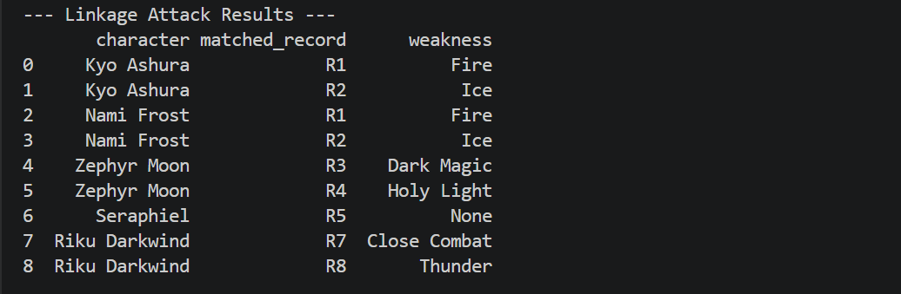
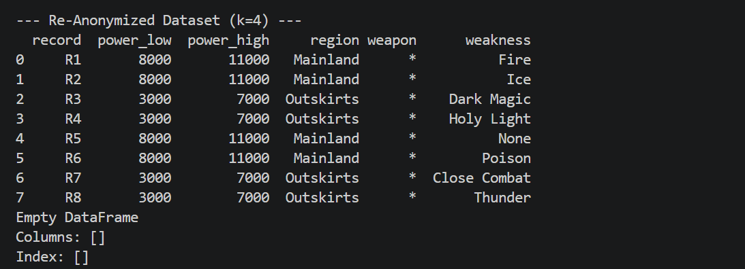

Section 2: l-Diversity

Concept Recap
l-Diversity extends k-Anonymity by requiring each equivalence class to contain at least l DISTINCT sensitive attribute values. This prevents homogeneity attacks, where an attacker infers a sensitive attribute because all k records in a class share the same value.

Lab 2.1 — OtakuHealth Clinic Patient Records

Scenario
OtakuHealth clinic wants to publish a k=3 anonymized patient dataset for academic research. Your task: (1) Build the dataset in Python, (2) implement a function to check l=2-Diversity, (3) identify which equivalence classes fail, and (4) propose and apply a fix.

Part A — Dataset (Already k=3 Anonymized)

Patient # | Age Group | City District | Convention Role | Diagnosis
P01 | Teen (13-19) | Shibuya | Attendee | Anxiety
P02 | Teen (13-19) | Shibuya | Attendee | Anxiety
P03 | Teen (13-19) | Shibuya | Attendee | Anxiety
P04 | Adult (20-35) | Harajuku | Cosplayer | Back Pain
P05 | Adult (20-35) | Harajuku | Cosplayer | Back Pain
P06 | Adult (20-35) | Harajuku | Cosplayer | Fatigue
P07 | Senior (36+) | Akihabara | Vendor | Hypertension
P08 | Senior (36+) | Akihabara | Vendor | Hypertension
P09 | Senior (36+) | Akihabara | Vendor | Hypertension
P10 | Adult (20-35) | Shibuya | Volunteer | Fatigue
P11 | Adult (20-35) | Shibuya | Volunteer | Fatigue
P12 | Adult (20-35) | Shibuya | Volunteer | Fatigue

Part B — Build the Dataset and Implement l-Diversity Check
import pandas as pd

# TODO: Build the patient DataFrame from the table above.
data = {
'patient_id': [...],
'age_group': [...],
'district': [...],
'role': [...],
'diagnosis': [...], # sensitive attribute
}
df = pd.DataFrame(data)

def check_l_diversity(df, qi_cols, sensitive_col, l):
"""
Checks if every equivalence class has at least l distinct sensitive values.
Prints a summary table of each EC and whether it passes.
Returns True if ALL ECs satisfy l-Diversity.
"""
# TODO: Group by qi_cols.
# For each group, count distinct values in sensitive_col.
# Print: QI values | distinct values | count | l satisfied?
# Return True only if all groups have >= l distinct sensitive values.
pass

qi = ['age_group', 'district', 'role']
check_l_diversity(df, qi, sensitive_col='diagnosis', l=2)

💡 Hints
Group the DataFrame: groups = df.groupby(qi_cols)
Count distinct sensitive values per group: groups[sensitive_col].nunique()
nunique() returns the number of UNIQUE values — this is your l count.
To print distinct values (not just count): groups[sensitive_col].unique()

Part C — Identify Failing ECs and Describe a Homogeneity Attack
Use your check_l_diversity function to identify which ECs fail l=2. Then answer:
# TODO: Run the check and collect failing ECs.
# Then: Suppose an attacker knows P07 is a Senior vendor from Akihabara.
# What diagnosis can they infer with certainty from the ORIGINAL dataset?

# Identify the EC for P07:
ec_p07 = df[
(df['age_group'] == 'Senior (36+)') &
(df['district'] == 'Akihabara') &
(df['role'] == 'Vendor')
]
print('EC for P07:')
print(ec_p07)
print('Distinct diagnoses:', ec_p07['diagnosis'].unique())

# TODO: Is this a homogeneity attack? Write your explanation as a comment.

💡 Pointer
A homogeneity attack occurs when ALL records in an EC share the same sensitive value.
If ec_p07['diagnosis'].nunique() == 1, that EC is homogeneous — an attacker knows the diagnosis.

Part D — Modify the Dataset to Satisfy l=2
Propose and implement a fix for each failing EC. You may (a) further generalize QIs to merge ECs, or (b) suppress records. Apply your fix and re-verify.
def fix_l_diversity(df, qi_cols, sensitive_col, l):
"""
Returns a modified DataFrame where all ECs satisfy l-Diversity.
Strategy options:
(a) Generalize QIs further to merge small homogeneous ECs into larger diverse ones.
(b) Suppress (drop) records that make an EC non-diverse.
Document your strategy in comments.
"""
df_fixed = df.copy()
# TODO: Apply your chosen fix.
# After fixing, call check_l_diversity(df_fixed, qi_cols, sensitive_col, l)
# to confirm all ECs now pass.
return df_fixed

df_fixed = fix_l_diversity(df, qi, 'diagnosis', l=2)
print('\nVerification after fix:')
check_l_diversity(df_fixed, qi, 'diagnosis', l=2)

# TODO: Verify P07 is no longer vulnerable.
# Print the EC that P07 now belongs to and list its distinct diagnoses.

⚠️ Design Choice
There is no single correct fix. But you must justify your approach in comments.
Merging ECs (by generalizing a QI) preserves more records but reduces specificity.
Suppression keeps QI specificity but loses records — bad if the dataset is already small.
Make sure after fixing, k=3 is STILL satisfied. Call check_k_anonymity on df_fixed too.

Rubric — Lab 2.1
Part B — Correct DataFrame + check_l_diversity implementation: 30 pts
Part C — Correct EC identification and homogeneity attack explanation: 30 pts
Part D — Correct fix + verification + P07 re-check: 40 pts
TOTAL: 100 pts

Lab 2.2 — MangaLeague Fan Tournament Score Sheet

Scenario
MangaLeague publishes anime trivia tournament score sheets for academic study. The sensitive attribute is 'Knowledge Level' (Novice / Intermediate / Expert / Master). Your task: (1) Build equivalence classes programmatically, (2) identify which violate l=3-Diversity, (3) generalize to achieve l=3, and (4) analyze a background knowledge attack.

Part A — Dataset

Fan ID | Age Range | Home Region | Favorite Series | Knowledge Level
F01 | 15-19 | Luzon | One Piece | Novice
F02 | 15-19 | Luzon | One Piece | Novice
F03 | 15-19 | Luzon | Naruto | Intermediate
F04 | 20-25 | Visayas | Attack on Titan | Expert
F05 | 20-25 | Visayas | Attack on Titan | Expert
F06 | 20-25 | Visayas | Attack on Titan | Master
F07 | 26-35 | Mindanao | Dragon Ball Z | Intermediate
F08 | 26-35 | Mindanao | Dragon Ball Z | Intermediate
F09 | 26-35 | Mindanao | Dragon Ball Z | Intermediate
F10 | 36+ | Luzon | Sailor Moon | Master
F11 | 36+ | Luzon | Sailor Moon | Master
F12 | 36+ | Luzon | Sailor Moon | Expert
F13 | 15-19 | Visayas | Demon Slayer | Novice
F14 | 15-19 | Visayas | Demon Slayer | Novice
F15 | 15-19 | Visayas | Demon Slayer | Intermediate

Part B — Build Dataset and Equivalence Class Summary
# TODO: Build the DataFrame from the table above.
data = {
'fan_id': [...],
'age_range': [...],
'region': [...],
'series': [...],
'knowledge': [...], # sensitive attribute
}
df = pd.DataFrame(data)

# TODO: Build an EC summary table.
# For each group of (age_range, region, series), compute:
# - Number of records in the EC
# - Distinct knowledge levels
# - Whether l=3 is satisfied (nunique >= 3)

qi = ['age_range', 'region', 'series']
ec_summary = (
df.groupby(qi)['knowledge']
.agg(records='count', distinct=pd.Series.nunique, levels=list)
.reset_index()
)
ec_summary['l3_satisfied'] = ec_summary['distinct'] >= 3
print(ec_summary.to_string(index=False))

💡 Hints
pd.Series.nunique counts unique values — use it with .agg().
Pass a list in .agg() to compute multiple aggregations: .agg(count=('knowledge','count'), nunique=('knowledge','nunique'))
To collect all values as a list: .agg(levels=('knowledge', list)) — useful for seeing the distribution.

Part C — Generalize to Achieve l=3
For each EC that fails l=3, apply further generalizations to merge it with other ECs until l=3 is met across all equivalence classes.
def generalize_series(series, level=1):
"""
level=1: group similar series under a genre label
level=2: collapse all to 'Anime'
Example groupings (you may define your own):
One Piece / Naruto / Dragon Ball Z -> 'Shonen'
Sailor Moon / Demon Slayer / Attack on Titan -> 'Modern Anime'
"""
# TODO: Implement.
pass

def generalize_age_range(age_range, level=1):
"""
level=1: '15-19' and '20-25' -> 'Under 25'
'26-35' and '36+' -> '26 and above'
level=2: all -> 'All Ages'
"""
# TODO: Implement.
pass

# Apply generalizations and re-check l=3
df_anon = df.copy()
df_anon['series'] = df_anon['series'].apply(lambda x: generalize_series(x, level=1))
df_anon['age_range'] = df_anon['age_range'].apply(lambda x: generalize_age_range(x, level=1))

check_l_diversity(df_anon, qi, 'knowledge', l=3)
# If still failing, increase level and repeat.

💡 Strategy Pointer
The Dragon Ball Z EC (F07–F09) is the most problematic: all three records have 'Intermediate'.
You must merge this EC with at least two others that have different knowledge levels.
Generalizing 'series' from 'Dragon Ball Z' to 'Shonen' would group it with F01–F03 (Luzon, 15-19) — check if that gives >= 3 distinct values.
After generalizing, re-check BOTH k and l using your previously written functions.

Part D — Background Knowledge Attack
Before and after your generalization, analyze whether F08 is protected.
# BEFORE generalization:
ec_f08_before = df[
(df['age_range'] == '26-35') &
(df['region'] == 'Mindanao') &
(df['series'] == 'Dragon Ball Z')
]
print('Before generalization, EC of F08:')
print(ec_f08_before['knowledge'].value_counts())
# TODO: What knowledge level can an attacker infer with 100% certainty?

# AFTER generalization:
# TODO: Filter df_anon to find F08's new EC.
# Print distinct knowledge levels in the new EC.
# Is F08 still uniquely identifiable?

Written Question: In your own words, explain the difference between a homogeneity attack and a background knowledge attack. Which one applies to F08 before generalization?
Your answer: Homogeneity Attack is the attacker compromises privacy because every single record in an equivalence class shares the exact same sensitive attribute. While Background Knowledge Attack is the equivalence class is diverse (like it contains 'Novice' and 'Master'), but the attacker uses outside information to rule out options, example: "I know F08 has watched anime for 20 years, so they cannot be a Novice. Therefore, they must be the Master". The one that applies to F08 before generalization was the Homogeneity Attack because their specific Dragon Ball Z equivalence class contained only 'Intermediate' records.
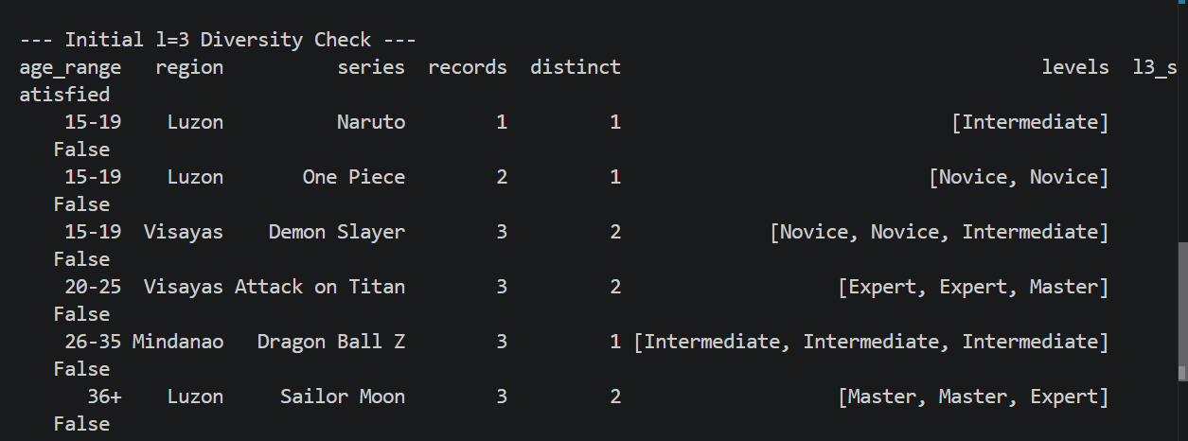
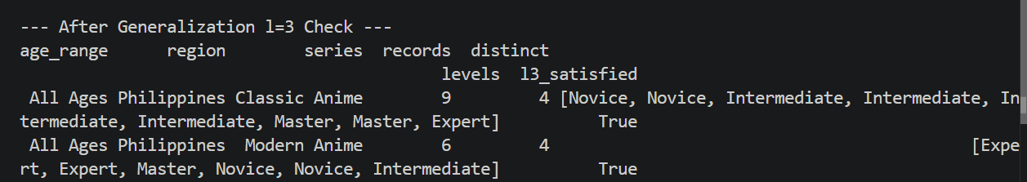
Rubric — Lab 2.2
Part B — EC summary table (correct groupby and nunique): 25 pts
Part C — Correct generalization achieving l=3 everywhere: 35 pts
Part D — Before/after code + written explanation: 40 pts
TOTAL: 100 pts

Section 3: t-Closeness

Concept Recap
t-Closeness requires that the distribution of the sensitive attribute within any equivalence class closely matches the overall distribution in the entire dataset. The distance between distributions is measured using the Earth Mover's Distance (EMD). If EMD ≤ t, the EC satisfies t-Closeness.
EMD for unordered categorical data: EMD = (1/2) × Σ |p_i - q_i|

Lab 3.1 — NihonStream Viewer Analytics

Scenario
NihonStream is an anime streaming service sharing viewer analytics with research institutions. The sensitive attribute is 'Viewer Tier' (Free / Silver / Gold / Platinum). The dataset has been k=4 anonymized. Your task: implement the EMD calculation in Python and check whether each EC satisfies t=0.25-Closeness.

Part A — Build the Dataset and Compute Overall Distribution
The 20-record dataset has three equivalence classes. Build the full DataFrame and compute the overall distribution of Viewer Tier.
import pandas as pd
import numpy as np

# EC1 (n=5): Free, Free, Silver, Free, Silver
# EC2 (n=7): Platinum, Platinum, Platinum, Gold, Gold, Gold, Silver
# EC3 (n=8): Free, Free, Free, Free, Silver, Silver, Gold, Platinum

# TODO: Build the full DataFrame with columns: ['ec', 'viewer_tier']
# Hint: Repeat EC labels for each record (e.g., 'EC1' repeated 5 times, etc.)

records = []
ec1_tiers = ['Free','Free','Silver','Free','Silver']
ec2_tiers = [...] # TODO: fill in
ec3_tiers = [...] # TODO: fill in

for tier in ec1_tiers: records.append({'ec':'EC1', 'viewer_tier': tier})
# TODO: Repeat for EC2 and EC3.

df = pd.DataFrame(records)

# Compute overall distribution
overall_dist = df['viewer_tier'].value_counts(normalize=True).sort_index()
print('Overall distribution:')
print(overall_dist)

💡 Hints
value_counts(normalize=True) gives proportions (floats summing to 1.0) instead of raw counts.
.sort_index() ensures consistent ordering (alphabetical) for later comparisons.
Store the overall distribution as a Python dict for easy lookup: overall_dict = overall_dist.to_dict()

Part B — Implement EMD Calculation
Implement the Earth Mover's Distance function for unordered categorical data.
def compute_emd_unordered(ec_dist, overall_dist):
"""
Computes EMD for unordered categorical sensitive attributes.
Formula: EMD = (1/2) * sum(|p_i - q_i|) for each category i

Parameters:
ec_dist (dict): proportion of each category in this EC
overall_dist (dict): proportion of each category in the full dataset

Returns:
float: the EMD value
"""
# TODO: Implement this function.
# Step 1: Get all unique categories (union of keys from both dicts).
# Step 2: For each category, get p_i (EC proportion, default 0 if missing)
# and q_i (overall proportion, default 0 if missing).
# Step 3: Sum |p_i - q_i| over all categories, then multiply by 0.5.
pass

# Example test (you can verify manually):
test_ec = {'Free': 0.6, 'Silver': 0.4, 'Gold': 0.0, 'Platinum': 0.0}
test_overall = {'Free': 0.40, 'Silver': 0.25, 'Gold': 0.20, 'Platinum': 0.15}
print(compute_emd_unordered(test_ec, test_overall)) # Expected: 0.175

💡 Step-by-Step Walkthrough
Categories = {Free, Silver, Gold, Platinum}
|0.60 - 0.40| = 0.20 (Free)
|0.40 - 0.25| = 0.15 (Silver)
|0.00 - 0.20| = 0.20 (Gold)
|0.00 - 0.15| = 0.15 (Platinum)
Sum = 0.70 → EMD = 0.70 / 2 = 0.35
Use dict.get(key, 0) to safely access keys that may not exist in an EC.

Part C — Check t=0.25-Closeness for Each EC
def check_t_closeness(df, ec_col, sensitive_col, overall_dist, t):
"""
For each unique value of ec_col, compute the EMD and check if <= t.
Prints a summary table.
Returns True if ALL ECs satisfy t-Closeness.
"""
all_pass = True
for ec_name, group in df.groupby(ec_col):
# TODO: Compute ec_dist from the group.
# Hint: group[sensitive_col].value_counts(normalize=True).to_dict()
ec_dist = ...
emd = compute_emd_unordered(ec_dist, overall_dist)
passes = emd <= t
if not passes: all_pass = False
print(f'{ec_name}: EMD={emd:.4f} t={t} Pass={passes}')
return all_pass

overall_dict = df['viewer_tier'].value_counts(normalize=True).to_dict()
check_t_closeness(df, 'ec', 'viewer_tier', overall_dict, t=0.25)

💡 Debugging Tip
If your EMD values seem too high or low, print ec_dist and overall_dict side by side for each EC.
Make sure both dicts cover ALL categories, defaulting missing ones to 0.
EC2 should fail t=0.25 because it is heavily skewed toward Platinum and Gold, which are rare overall.

Part D — Propose a Fix and Analyze Trade-offs
For the failing EC(s), describe a generalization strategy and implement it. Then answer the trade-off question in code comments.
# TODO: Propose and implement a fix for the violating EC.
# Strategy options:
# (a) Merge EC2 with another EC by further generalizing a QI.
# (b) Suppress some records from EC2 to rebalance the distribution.
# (c) Split EC2 into smaller groups (only if k is still satisfied).

# After modifying df, re-run check_t_closeness to verify.

# TODO: Answer in comments:
# Q1: What happens to data utility if t is set very small (e.g., t=0.01)?
# Q2: What privacy risk arises if t is set very large (e.g., t=0.90)?
ANSWER 1:
If $t$ is extremely small, the threshold is so strict that every equivalence class must have an almost identical distribution to the overall dataset. To achieve this, you would have to generalize and merge almost all the records together into one massive group. This destroys data utility because researchers can no longer analyze specific subsets of the data (like specific age groups or regions).
ANSWER 2:
If $t$ is too large, the threshold is too loose, allowing equivalence classes to have distributions that are wildly different from the overall average (just like the original EC2). This completely defeats the purpose of t-Closeness and exposes the dataset to Skewness Attacks, where an attacker can infer a user's sensitive attribute with high confidence because their specific group is heavily skewed toward one rare value.

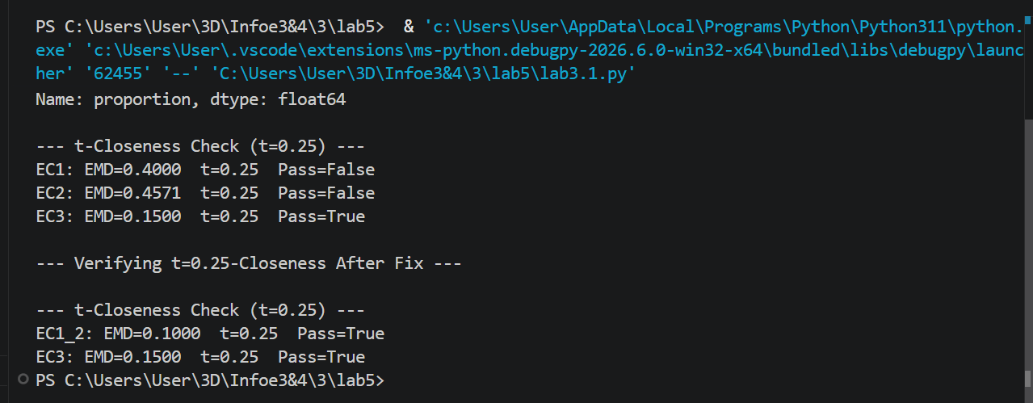
Rubric — Lab 3.1
Part A — Correct DataFrame and overall distribution: 15 pts
Part B — Correct compute_emd_unordered implementation: 30 pts
Part C — Correct check_t_closeness and correct identification of violating EC: 30 pts
Part D — Fix proposal + trade-off analysis comments: 25 pts
TOTAL: 100 pts

Lab 3.2 — AniMed Hospital Fan Event Medical Records

Scenario
AniMed Hospital wants to publish anonymized health records satisfying ALL THREE simultaneously: k=4, l=2, and t=0.30-Closeness. Sensitive attribute: Blood Condition (Normal / Anemia / Pre-diabetic / Hypertensive). This is a DESIGN + VERIFICATION lab: you will design a generalization scheme and verify it meets all three criteria using your Python functions.

Part A — Dataset

Patient ID | Age Group | Cosplay Type | Days Attended | Blood Condition
M01 | 18-22 | Shonen Hero | 1 Day | Normal
M02 | 18-22 | Shonen Hero | 1 Day | Normal
M03 | 18-22 | Shonen Hero | 1 Day | Anemia
M04 | 18-22 | Shonen Hero | 1 Day | Anemia
M05 | 23-30 | Magical Girl | 2 Days | Normal
M06 | 23-30 | Magical Girl | 2 Days | Pre-diabetic
M07 | 23-30 | Magical Girl | 2 Days | Hypertensive
M08 | 23-30 | Magical Girl | 2 Days | Normal
M09 | 31-40 | Mecha Pilot | 3 Days | Hypertensive
M10 | 31-40 | Mecha Pilot | 3 Days | Hypertensive
M11 | 31-40 | Mecha Pilot | 3 Days | Hypertensive
M12 | 31-40 | Mecha Pilot | 3 Days | Pre-diabetic
M13 | 41+ | Classic Villain | 2 Days | Normal
M14 | 41+ | Classic Villain | 2 Days | Anemia
M15 | 41+ | Classic Villain | 2 Days | Hypertensive
M16 | 41+ | Classic Villain | 2 Days | Pre-diabetic

Part B — Build the Dataset and Compute Overall Distribution
# TODO: Build the DataFrame from the table above.
data = {
'patient_id': [...],
'age_group': [...],
'cosplay': [...],
'days': [...],
'condition': [...], # sensitive attribute
}
df = pd.DataFrame(data)

# Compute overall distribution
overall_dist = df['condition'].value_counts(normalize=True).to_dict()
print('Overall distribution of Blood Condition:')
for k_cond, v in sorted(overall_dist.items()):
print(f' {k_cond}: {v:.4f}')

Part C — Design Generalizations and Assign ECs
You must design a generalization scheme that creates equivalence classes satisfying all three criteria. Implement it as a function that adds a new 'ec' column to the DataFrame.
def assign_equivalence_classes(df):
"""
Adds an 'ec' column to df by generalizing quasi-identifiers.
Each EC must have: k>=4, l>=2, EMD<=0.30

Generalization ideas:
Age: '18-22' + '23-30' -> 'Young Adult (18-30)'
'31-40' + '41+' -> 'Middle-Older (31+)'
Cosplay: 'Shonen Hero' + 'Magical Girl' -> 'Popular Anime'
'Mecha Pilot' + 'Classic Villain' -> 'Classic Anime'
Days: '1 Day'+'2 Days' -> '1-2 Days'
'3 Days' alone -> '3 Days'
You may use ANY valid scheme — justify your choices in comments.
"""
df = df.copy()
# TODO: Create generalized columns.
# TODO: Assign EC labels based on generalized QI combinations.
# Example: df['ec'] = df['age_gen'] + '_' + df['cosplay_gen']
return df

df_anon = assign_equivalence_classes(df)
print(df_anon[['patient_id','ec','condition']].to_string(index=False))

💡 Design Guidance
Start by checking which ECs violate which criterion — failing one informs your generalization choice.
EC M09–M12 (Mecha Pilot, 31-40, 3 Days) all have 'Hypertensive' or 'Pre-diabetic' — l=2 might be borderline.
To meet t=0.30: Normal ~31%, Anemia ~19%, Pre-diabetic ~25%, Hypertensive ~25% overall — your EC distribution must not deviate too far.
Run all three checks (k, l, EMD) after each attempt and iterate.

Part D — Verify All Three Criteria
Use your functions from Labs 1.1, 2.1, and 3.1 to verify each EC satisfies k=4, l=2, and t≤0.30.
qi = ['ec'] # EC label encodes the generalized QI combination

print('=== k=4 CHECK ===')
check_k_anonymity(df_anon, qi, k=4)

print('\n=== l=2 CHECK ===')
check_l_diversity(df_anon, qi, 'condition', l=2)

print('\n=== t=0.30 CHECK ===')
overall_dict = df['condition'].value_counts(normalize=True).to_dict()
check_t_closeness(df_anon, 'ec', 'condition', overall_dict, t=0.30)

# TODO: If any check fails, go back to Part C and revise your generalizations.
# Document each iteration in comments: what failed, what you changed, and why.

⚠️ Important
All three checks must pass simultaneously on the SAME df_anon.
It is acceptable to iterate 2-3 times before finding a valid scheme — document your attempts.
If a check function returns False, read its printed output to see WHICH EC is failing.

Part E — Comparative Analysis (Written Answers)
E1. Compare k-Anonymity, l-Diversity, and t-Closeness. For this medical dataset, which provides the strongest privacy protection? Use specific EC examples from your implementation to justify.
Your answer: t-Closeness provides the strongest protection. While k-Anonymity hides the patient in a group of 8 (e.g., the 18-30_Popular Anime_1-2 Days class) and l-Diversity ensures 4 different conditions exist, t-Closeness guarantees that the specific proportion of those conditions doesn't skew heavily towards one rare disease. By forcing the internal distribution to match the overall population (an EMD of 0.2500), it completely prevents an attacker from using statistical skewness to infer a patient's health condition.
E2. As the privacy officer at AniMed, would you choose t=0.05 or t=0.40? Defend your choice considering both research utility and patient privacy.
Your answer: I would choose t=0.40. If t=0.05 is chosen, the threshold is so strict that we would have to generalize the entire dataset into a single global class to pass the check, destroying all research utility. A threshold of t=0.40 allows for enough variation in the equivalence classes to preserve granularity allowing researchers to correlate age or cosplay types with health trends, while still providing a solid baseline defense against severe statistical skewness.
E3. Describe one scenario where t-Closeness alone would still fail to protect a patient's privacy. What additional measure would you combine it with?
Your answer: t-Closeness fails if the entire overall dataset is highly sensitive or homogeneous. For example, if the hospital dataset only contains patients who have terminal cancer, the overall distribution is 100% terminal cancer. An equivalence class perfectly matching that 100% distribution satisfies t-Closeness but offers zero privacy. To fix this, I would combine it with Differential Privacy (injecting statistical noise) or simply suppress the publication of the dataset entirely.
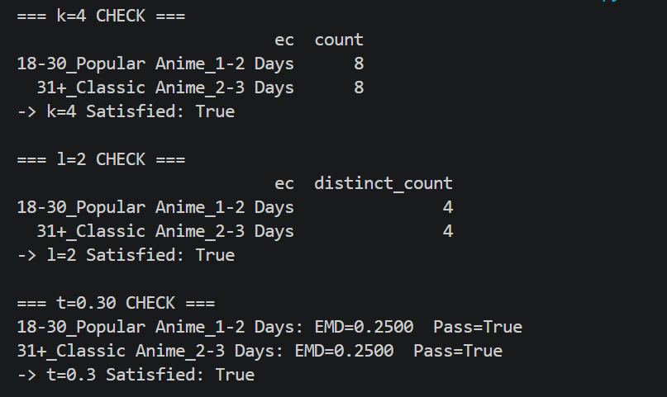
Rubric — Lab 3.2
Part B — Correct DataFrame and overall distribution: 10 pts
Part C — Valid generalization scheme with comments: 30 pts
Part D — All three checks pass + iteration documentation: 30 pts
Part E — Written analysis (10 pts each): 30 pts
TOTAL: 100 pts

Technique Comparison Summary

After completing all six labs, fill in the table and write your synthesis paragraph.

Property | k-Anonymity | l-Diversity | t-Closeness
Core Requirement | Each EC has >= k identical QI records | Each EC has >= l distinct sensitive values | EC distribution matches overall by <= t (EMD)
Prevents | Re-identification / Linkage Attack | Homogeneity Attack, Background Knowledge Attack | Skewness Attack, Similarity Attack
Main Weakness | All records in EC may share one sensitive value | Values may still be skewed in one direction | Difficult to define distance for non-ordered data
Python Function (you wrote) | check_k_anonymity() | check_l_diversity() | compute_emd_unordered() + check_t_closeness()
Lab Used In | 1.1 and 1.2 | 2.1 and 2.2 | 3.1 and 3.2
Best Used For | (fill in) | (fill in) | (fill in)

Synthesis Paragraph
In 3–5 sentences, explain how these three techniques complement each other when applied together (as in Lab 3.2):
These three techniques build upon each other to form a defense-in-depth strategy. k-Anonymity provides the foundational layer by hiding individuals within a crowd, preventing direct re-identification via quasi-identifiers. l-Diversity strengthens this by ensuring the crowd doesn't all share the exact same sensitive secret, defeating homogeneity attacks. Finally, t-Closeness refines the defense by guaranteeing the distribution of secrets in that crowd mirrors the general population, preventing attackers from using statistical skewness to infer sensitive information.

References
- Li, N., Li, T., & Venkatasubramanian, S. (2007). t-Closeness: Privacy beyond k-anonymity and l-diversity.
- Machanavajjhala, A., Kifer, D., Gehrke, J., & Venkatasubramanian, M. (2006). l-diversity: Privacy beyond k-anonymity.
- Domingo-Ferrer, J., Soria-Comas, J., & Gonzalez-Nicolas, U. (2016). Enhancing data utility in differential privacy.
- Rajendran, K., et al. (2018). Applications of data anonymization in healthcare and related domains.

All scenarios, datasets, and character names in this workbook are entirely fictional and created for educational purposes.

